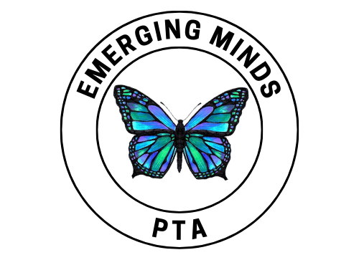
Sponsorship Packet 2025-2026

Emerging Minds PTA | 16705 Puzzle Place | Delray Beach FL 33446

Contact us at emergingmindspta@gmail.com




ABOUT US

OUR MISSION & VISION
The mission of the Emerging Minds PTA, which was established in 2018, is to support the educational experience of each student, ensuring they can work to their full potential.
Additionally, the Emerging Minds PTA works to empower and support staff in their efforts to maintain the highest educational Montessori standards and promotes communication between students, faculty and parents to create a sense of community. We further embrace the mission of the Florida PTA in advocating for children, and promoting welfare in all aspects of their lives.
The vision of the Emerging Minds PTA is in alignment with the Florida PTA, and with Montessori pedagogy: To make every child’s potential a reality.

WHO WE HELP
As a PTA, we are able to help:
our students by enhancing educational experiences through funded programs and resources
our teachers and staff by funding additional resources and materials for classrooms, funding continuing education opportunities and planning appreciation events
our parents and guardians by providing opportunities for involvement and volunteerism and providing communication and updates on school activities
our local community by planning events and programs open to the community, building partnerships with local businesses and organizations and providing support for local initiatives and causes

Our Impact

“The greatest gift we can give our children are the roots of responsibility and the wings of independence.” - Maria Montessori





Last year, we funded:
5
Fundraising Events
$5,000
Continuing Education
6
Family Events
$4500
Classroom Enhancements
5
Field Trips

Our Upcoming Goals

To increase the number of family events, and continue to diversify what they are.

To bring together the school community in meaningful and memorable ways.

To be a bridge between the students, families, and school; facilitating lasting and positive impacts that
benefit all.





Why We Need Your Help

Sponsors help to support programs, events, and resources that are not covered by our school's budget.
Sponsors enable us to offer enriching activities, such as special programs and field trips that enhance our students' educational experiences.
Sponsors help fund initiatives like teacher appreciation and community- building events that foster a positive school culture.
Sponsors facilitate connections between local businesses and our school community, promoting mutual support and investment in education.




Why Be a Sponsor?
Through sponsoring the Emerging Minds PTA, you'll be investing in the education and well-being of our students, while also connecting with local families who share your values. Your support will help fund enriching programs, events, and materials that foster independent learning, creativity, and community. In return, you'll receive recognition and visibility within our tight-knit school community, including promotion to our engaged parents and social media networks. Join us in empowering our children to become compassionate, curious, and innovative leaders.

Sponsorship Opportunities




Support Emerging Minds PTA by becoming a valued sponsor!

Our sponsorship program offers various levels to fit any budget, from
$100 to $10,000. Your contribution will help provide vital resources and programs for our students.

In return, you'll receive recognition and appreciation from our school community. Join us in enriching the educational experience for our students.

Apply for sponsorship by completing the following sponsorship form or by emailing emergingmindspta@gmail.com


Emerging Minds PTA Sponsorship Agreement
CONTACT INFORMATION (please print)

Donor/Company Name: Contact Name/Title: Address: City: State: Zip: Phone: Email:

SPONSORSHIP OPPORTUNITIES

Please put a check next to the opportunity of your choosing.

Emerging Minds Friend ($100)
- One sponsor recognition email sent to all families during the school year
- Logo on the PTA website for the school year

Emerging Minds Supporter ($500)
- Everything included with the Emerging Minds Friend level, plus
- Thank you and logo in a school newsletter
- One pinned recognition story on PTA Facebook and Instagram pages and school FB/Instagram pages – pinned for one month

Emerging Minds Contributor ($1,000)
- Everything included with the Emerging Minds Supporter level, plus
- Thank you and logo in two school newsletters
- Option to set up a table with vendors at our two large school events
- Logo added to sponsor banner (shared logos)
- One time flyer/coupon distribution school-wide for students and staff

Emerging Minds Advocate ($2,500)
- Everything included with the Emerging Minds Contributor level, plus
- Private/company dedicated 3x5 banner with company logo in high-visibility area for 2 months during school year

Emerging Minds Ambassador ($5,000)

- Everything included with the Emerging Minds Advocate level, plus
- Private/company dedicated 3x5 banner in high-visibility area for entirety of school year

Emerging Minds Visionary ($10,000)
- Everything included with the Emerging Minds Ambassador level, plus
- Butterfly plaque displayed prominently on the school gratitude wall

PAYMENT INFORMATION
PAYMENT INFORMATION

Check enclosed payable to Emerging Minds PTA
Please invoice with payment link through CheddarUp (Processing Fees may apply)

Please return completed sponsorship agreement to the Emerging Minds PTA by emailing us at emergingmindspta@gmail.com and mail payment to: Emerging Minds PTA | 16705 Puzzle Place, Delray Beach FL 33446

Questions? Contact the Emerging Minds PTA Board at emergingmindspta@gmail.com
Thank you for your generous support of Emerging Minds Montessori Academy!

